COMPUTER ENGINEERING DEPARTMENT
Bilkent University

CS 351: Data Organization and Management
Final Exam (Section 2 & 3)
Dec. 23, 2005 – 12:15 – 14:15 NAME/Section:

GOOD LUCK!
Notes: 1. There are 100 points, 9 questions on 8 pages.
2. Please first READ the questions and then provide short answers.
3. Show your work.
4. You are not allowed to use your cell phone or PDA for any purpose.
5. Before proceeding with the questions please read the last page, Appendix, ⬅
for IBM 3380 parameters and further instructions.

1. (10 pts.) In this question consider an inverted file-based search engine environment.

No. of Query  Terms | 1 | 2 | 3 | 4 | 5
Probability | .2 | .4 | .2 | .1 | .1

The above table indicates that 20% of the queries contain 1 term (i.e., their probability is .2), similar interpretations are valid for the other entries of the table.

In the same environment, the posting lists have the following characteristics in terms of their length (in number of thousand disk blocks).

Posting list  Length  (in 1000 blocks) | 1 | 2 | 3 | 4
Probability | .4 | .4 | .1 | .1

The above table indicates that, for example, 40% of the posting lists occupy 1000 disk block.

a. Determine the expected number of terms in an average query.

Answer:
Expected number of terms = 1 x 0.2 + 2 x 0.4 + 3 x 0.2 + 4 x 0.1 + 5 x 0.1 = 2.5
Thus, an average query has about 3 terms.

- What is the expected number of posting disk blocks to be accessed for an average query?

Answer:
For each term the number of posting disk blocks to be accessed is :
1000 x (1 x 0.4 + 2 x 0.4 + 3 x 0.1 + 4 x 0.1) = 1900
As we have 3 terms in an average query, the expected number of posting disk blocks to be accessed is : 3 x 1900 = 5700

- What is the expected query processing time if we assume that in a posting list 80% of the disk blocks are allocated sequentially and the rest randomly. Assume an IBM3380 environment.

Answer:
Let the number of sequentially allocated blocks be b_{s} and randomly allocated blocks be b_{r}.
Then the expected query processing time is calculated with the formula
b_{s} x ebt + b_{r} x (s + r + btt)
Using the average number of blocks to be accessed (calculated in b) and the IBM 3380 specifications we get query processing time = 5700 x 0.8 x 0.84 + 5700 x 0.2 x (16 + 8.3 + 0.8)
= 32444 ms = 32 sec.

2. (10 In a university database we have information about professors (with SSN), courses (with courseid). Professors teach courses. Between these two items, there is Teaches relationship. (This question is tricky, and some of the drawings may not match the specifications.)

a. Professors can teach the same course in several semesters, and each offering must be recorded. Draw an ER diagram for this specification.

Answer:

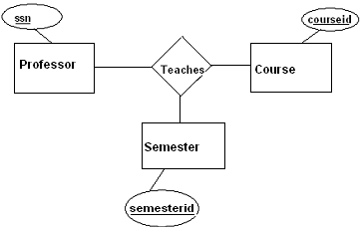

b. Consider the following specification and the following ER diagram and state if the given diagram matches the specification given below. If you’re answer is "No." Explain the problem.
Specification: Professors can teach the same course only once in a specific semester.

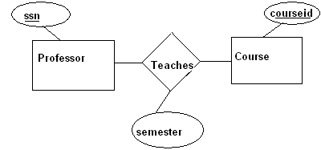
Answer:
No. A professor can be teaching the same course twice in a given semester, but only one of those can be recorded according to the given model as the key attributes are only ssn and courseid.
c. For the following ER diagram specify the relationship between the entities Professor and Course.

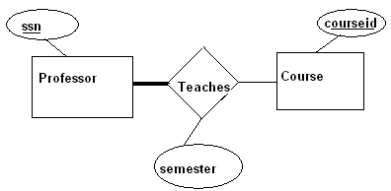
Answer:
Each professor teaches at least one course. (total participation)
d. For the following ER diagram specify the relationship between the entities Professor and Course.
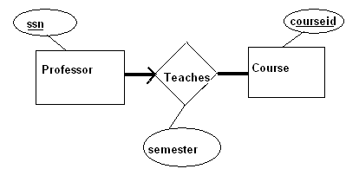
Answer:
Each professor teaches exactly one course and each course must be taught by some professor.

3. (12 pts.) Consider the relation instance for the Enroll(stuNo, stuName, Gpa, Hours) relation.
stuNo stuName Gpa Hours
111 Ali 3.00 115
222 Veli 3.20 100
333 Hasan 4.00 110
444 Huseyin 2.00 128
555 Ahmet 4.00 90
666 Fatma 2.50 110

What will be displayed by the following query? Explain the purpose of the query.
SELECT x.stuName, y.stuName
FROM Enroll x, Enroll y
WHERE x.Hours = y.Hours

Answer:
The result of the given query is something like:
Ali Ali
Veli Veli
Hasan Hasan
Hasan Fatma
Huseyin Huseyin
Ahmet Ahmet
Fatma Hasan
Fatma Fatma

The purpose of the query is to find the student pairs who have studied for the same number of
hours.

Write the CREATE TABLE SQL statement for the above relation.

Answer:
CREATE TABLE Enroll(
stuNo INTEGER,
stuName CHAR(12),
Gpa REAL,
Hours INTEGER,
PRIMARY KEY (stuNo))

Define the terms logical and physical data independence.
Answer:
Logical data independence is shielding users from the changes in the logical structure of data, or the changes in the choice of relations to be stored. E.g. a relation can be replaced by two relations that are equivalent to the previous one and the user will get the same results for the same query.
Physical data independence is isolating the user from changes in the physical storage details. It hides details such as how data is laid out on disk, the file structure, and the choice of indexes.
4. (12 pts.) B and B+ tree related questions. Short answers please.

a. What is the most important advantage of B+ tree compared to B tree?

Answer:
B+ tree has a shallower tree structure than a B tree with the same records and it provides uniform access time, whereas in a B tree access times for different records are different.

b. Indicate one important advantage of B+ tree compared to ISAM

Answer:
A B+ tree can reorganize itself dynamically when new records are added and no overflow area is required to store the records, whereas ISAM needs overflow buckets and requires frequent reorganization when a lot of record additions are required.

c. Is the tree given below a B tree or B+ tree or none? What is its degree?

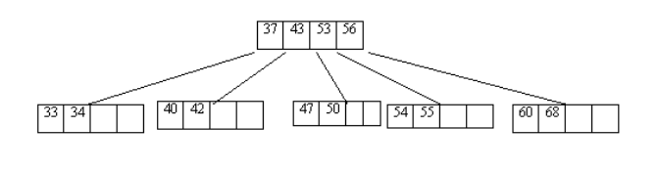
Answer:
The tree given is a B tree. It is of degree 2.

- Show the new tree after the insertion of the records with the key values 135, 200, 100 to the above tree if it’s a proper tree structure. (During grading I will greatly pay attention to the correctness of the final structure.)
Answer:

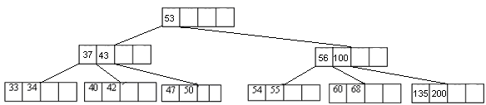

- How long does it take to exhaustively read all of the records of a file of 4 million records in order in a B+ tree (assume an IBM3380 environment)?
Answer:
In the IBM3380 environment, each block holds at most 6 records. If we assume that we have a typical B+ tree (which is ln2 full), we will have about 4 records in each bucket. Thus we need 1000000 buckets.
T_{x} = b x ebt = 1000000 x 0.84 = 840000 ms = 840 sec = 14 min. (we ignore s and r as they are relatively small)
5. (10 pts.) An orchestra database consists of the following relations:
CONDUCTS (Conductor, Composition)
REQUIRES (Composition, Instrument)
PLAYS (Player, Instrument)
LIKES (Player, Composition)

a. Give the natural language equivalent of the following query. Please write a short and clear answer.
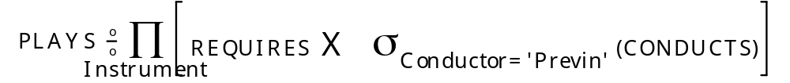Answer:
The players who can play all the instruments required in the compositions conducted by the conductors named ‘Previn’.

b. Write a query in relational algebra for the following request.
List the players and their instruments who can be work in the orchestra when John Williams conducts. Write your query step by step and explain each step.
Answer:
p( R1, σ _{Conductor = ‘John Williams’} (CONDUCTS) ) → choose the conducts relations the
conductor of which are John Williams
p( R2, Π _{Composition} R1 ) → List the compositions of John Williams
p( R3, R2 REQUIRES ) → get the compositions of John Williams and the
respective instruments required in them.
p( R4, Π _{Instrument} R3 ) → Get the instruments required in compositions of John
Williams
p( R5, R4 PLAYS ) → Get the players and their instruments which are in the
instruments required in the compositions of John Williams

6. (12 pts.) An unsorted (pile) file contains 100,000 records of 400 bytes each with a block size of 2400 bytes in the IBM3380 environment. In every 10 minutes, 3 records are added and 1 record is deleted until the total number of active records is 150,000?

a. How long does it take to come to the state of reorganization?
Answer:
Let n be the number of 10 minutes that pass before coming to the state of reorganization. The number of records increases by 2 each 10 minutes. Thus, 100,000 + 2n = 150,000
→ n = 25000
It takes 25000 x 10 = 250,000 minutes = 174 days to come to the state of reorganization.
b. How long does it take to find a record right before reorganization?
Answer:
Before reorganization, we have to search among 150,000 + 25,000 = 175,000 records (as we also look at the deleted records) → T_{F} = b/2 x ebt where b (number of blocks) is 175,000/ 6 = 29167 → T_{F} = 29167/2 x 0.84 = 12250 ms = 12 sec.

c. How long does it take to find a record right after reorganization?
Answer:
We search among only the active records →T_{F} = ((150,000 / 6) / 2) x 0.84 = 10500 ms =11 sec.
7. (12 pts.) Consider the following k-d (2-d) tree structure.
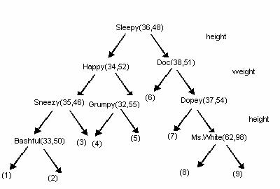

Consider the root node: Sleepy (36, 48).
The first number is the height (in inches) and the second number is the weight (in pounds) of Sleepy. In the construction of the tree, we first use the first information (height) and then the second information (weight). The leaves, shown by (1) … (9), are used to point to data buckets.

- Show the locations of the leaves on a two-dimensional x-y plane. Use the x-axis for height and the y-axis for weight. For height assume the range [0, 100], and for weight assume the range [0, 200]. In the x-y plane use the origin to indicate 0 height and 0 weight.

Answer:

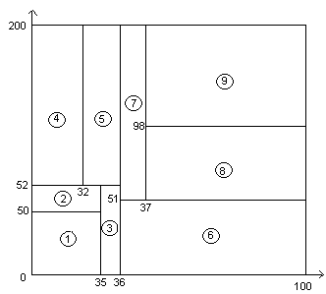

- Show the location of Prince Charming. He is 75 inches high and weights 180 pounds. Do the same for Clever (36 inches and 53 pounds).

Answer:
Prince Charming is in region 9. Clever is in region 5.
8. (12 pts.) Consider the following grid structure for a Grid File.
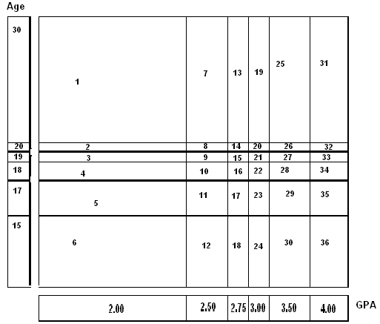
Assume that the above grid is kept in the main memory and the file is stored in an IBM3380 environment (see the Appendix!). Each number given in the coordinates indicates the maximum attribute value for the corresponding cell.
a. What is the maximum number of records that can be stored in a Grid File using the grid given above? Briefly explain.

Answer:
The maximum storage case occurs when all the regions in the given grid structure point to full data blocks. Using IBM3380 specifications, a block holds at most 6 records and in the grid structure we have 36 regions, thus the maximum number of records that can be stored is 6 x 36 = 216.

b. How many data blocks do we need to access for the following range queries using the above grid structure. For each case indicate the cell numbers to be used. Please list the cell numbers in ascending order.

Display StuName where 2.50 < GPA <= 3.50

Answer:
Cell numbers used: 13, 14, 15, 16, 17, 18, 19, 20, 21, 22, 23, 24, 25, 26, 27, 28, 29, 30
Number of blocks accessed is 18

Display StuName where 17 < Age <= 19
Answer:
Cell numbers used: 3, 4, 9, 10, 15, 16, 21, 22, 27, 28, 33, 34
Number of blocks accessed is 12.

Display StuName where 2.50 < GPA <= 3.50 or 17 < Age <= 19

Answer:
Cell numbers used: 3, 4, 9, 10, 13, 14, 15, 16, 17, 18, 19, 20, 21, 22, 23, 24, 25, 26, 27,
28, 29, 30, 33, 34
Number of blocks accessed is 24.

c. What is the I/O time to process the third query given above?
Answer:
To perform the given query, 24 data blocks have to be read.
→ I/O time = b x (s + r + btt) = 24 x (16 + 8.3 + 0.8) = 602.4 msec.

9. (10 pts.) In Linear Hashing environment suppose that the boundary value is 12.
a. How many primary area buckets are present? Draw a figure to show the file structure and indicate the position of bv on your figure.
Answer:
bv = 12 = 1100, we have 12 buckets before the boundary, then we have 1101, 1110 and 1111 and 12 buckets again. Thus, we totally have 12 + 4 + 12 = 28 primary area buckets.
The file structure is something like:
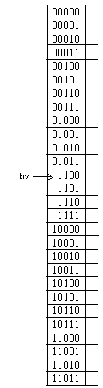
b. How many buckets are addressed with h bits? (Note that h indicates the hashing level
for the file.)
Answer:
The 4 buckets starting with 12 and going up till 15 are addressed using h bits.
c. How many with h+1 bits?
Answer:
The remaining 28 – 4 = 24 buckets are addressed with h+1 bits.
d. What is the value of h?

Answer:
As the boundary value (12 = 1100) can be represented with 4 bits, h = 4.

APPENDIX: IBM 3380 Parameters

When indicated or needed please assume an IBM 3380 like environment with the following parameters.

B block size 2400 bytes
Bfr no. of records per block 6
btt block transfer time 0.8 ms (data transfer rate is 3000 bytes/ms)
ebt effective block transfer time 0.84 ms (effective data transfer rate is 2857 bytes/ms)
r average rotational latency time 8.3 ms
s average seek time 16 ms

